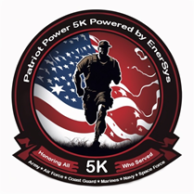 Patriot Power 5K Donation Form
Sponsor/Donor Information
(Company Name) | (Contact Name)
(Address) | (E-mail)
(City, State and Zip) | (Phone)
(Web Site)

Donation/Sponsorship
Check One: Cash/Check Product/Item Service Other
(Amount/Description) | (Date)
Notes:

Contact Information
Race Brimstone EnerSys Sara Appleman
6800 Feeder Run Cir NW 2366 Bernville Rd. Sara.Appleman@enersys.com
Canal Fulton, OH 44614 Reading, PA 19605 (610) 208-1647
Jeremy Followay
racebrimstone@gmail.com

Please make checks out to:
Race Brimstone (Patriot Power 5K)
Send checks and donation forms to:
Race Brimstone
6800 Feeder Run Cir NW
Canal Fulton, OH 44614

Please send all logos and artwork to Sara Appleman Email: sara.appleman@enersys.com

If claiming a tax credit for your charitable donation the 501c3 tax ID numbers are listed below for both organizations.
Team RWB: 27-2196347
BVO: 87-3683034

If you have any other questions or need anything else, please let us know.
Email: sara.appleman@enersys.com

Thank you for your support!

